Data transmission to a portable speaker using Li-Fi technology and solar charger for smart phones.

Pavan teja B Diwakar babu Suraj R bellad Pawan V

Dept. of CSE Dept.of CSE Dept. of CSE

CMR institute of technology CMR institute of technology CMR institute of technology

[Pavantej937@gmail.com](mailto:Pavantej937@gmail.com) [surajbellad03@gmail.com](mailto:surajbellad03@gmail.com) pawv16cs@cmrit.ac.in

**ABSTRACT**

The main aim of the paper is to demonstrate the application of Li-Fi (Light Fidelity) by operating a speaker. We narrow this paper down to find a substitute to WiFi which we use pass data to a portable speaker instead of other conventional methods i.e. (Bluetooth, WiFi). The high data transfer, throughput, data security makes Li-Fi more advantageous over WiFi.

Since mobile is a daily driver for almost everyone we take this research one step further by providing a portable charger for mobile phones using solar panel . The mobile is charged simultaneously when the speaker is switched on. We can use this concept domestically or for industrial purposes for managing devices more efficiently and with ease because we can use LED light to transmit data.

**Keywords:** Li-Fi: Light Fidelity, Wi-Fi: Wireless Fidelity, Bluetooth, solar panel, portable charger.

**I**. **INTRODUCTION**

Today communication technology is grown to such an extent that communicating across the corners of the globe is very easy. The telecommunication satellites and optical communication are the two major reasons for communication. The main concern of this paper is to communicate with a speaker via LiFi using a LED light bulb which is fitted with a chip which modulates the imperceptibly for optical data transmission. The LED powered by a 9V battery is connected to a mobile through aux from which the speaker is controlled. The light from the LED bulb is captured through a solar cell array which in turn converts it into electrical signals which helps in controlling the speaker. These electrical signals are then passed to the speaker via an aux cable as well. Li-Fi provides highly reliable and secure data transfer as light cannot penetrate walls and therefore not accessible to those who are not in the room and thus the speaker can be controlled only by people in the room. When compared to Wi-Fi the data throughput and data security is relatively high for Li-Fi. We use energy sources like electricity to power or charge devices which are non-renewable resources and expensive. Thus using solar energy to charge the smart phones is also an aim of this paper. From the solar cell we connect a micro usb cable to connect it to a mobile device to charge it. To charge it we expose the solar cell to sunlight,

This charges the mobile phone. The speed of charging depends on the day time and amount of sunlight available.

**II. LITERATURE SURVEY**

Li-Fi a term introduced by Herald Hass is a wireless optical networking technology which uses light emitting diodes (LED's) for data transmission. Li-Fi uses light bulbs similar to those which are used in energy-conscious homes and offices therefore making it readily available. The data transmitted by these light bulbs are received by photoreceptors of other devices. In earlier times the speed of the transmission was restricted to 150Mbps.

But recent studies with stronger LED's and different technology, researchers have enabled it to 10Gbps which is faster than 802.11ad.We see a potential in Li-Fi because of its benefits stated below:

* It prevents Piggybacking -Piggybacking is the intent of getting access of unrestricted WiFi. Li-Fi prevents it as the light cannot penetrate walls and hence restricting the access.
* The data being transmitted is not hindered by any radio frequencies thus making it very reliable.
* The transmission does not create interference in sensitive electronic devices thus making it better to use it in environments like hospitals and aircrafts.
* By including all the light-sources around the building we can enable larger area of coverage than a single WiFi router.
* We need to have a clear line of sight to achieve the same.

**III. DESIGN AND IMPLEMENTATION**

**A. ARCHITECTURE**

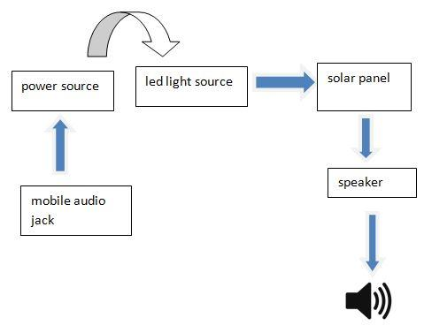

Figure 1: Architecture of the model

**Power source**: A 9v/15v dc voltage is used to power the speaker. The power supply is regulated using a 100 ohm resistor so as to control the flow of current.

**Solar panel**: A solar panel is a array of cells used to convert sunlight into electricity. Prisms or glass is used to concentrate sunlight into a narrow area so as to increase intensity of sunlight. Photovoltaic cells convert light into electric current using photoelectric effect.

**Li-Fi module:** This contains the amplifier circuit which amplifies the current transmitted from the solar panel so as to power the speaker.

**Speaker:** This is used to output the audio signal. It is connected to solar panel which acts as receiver.

**B. WORKING**

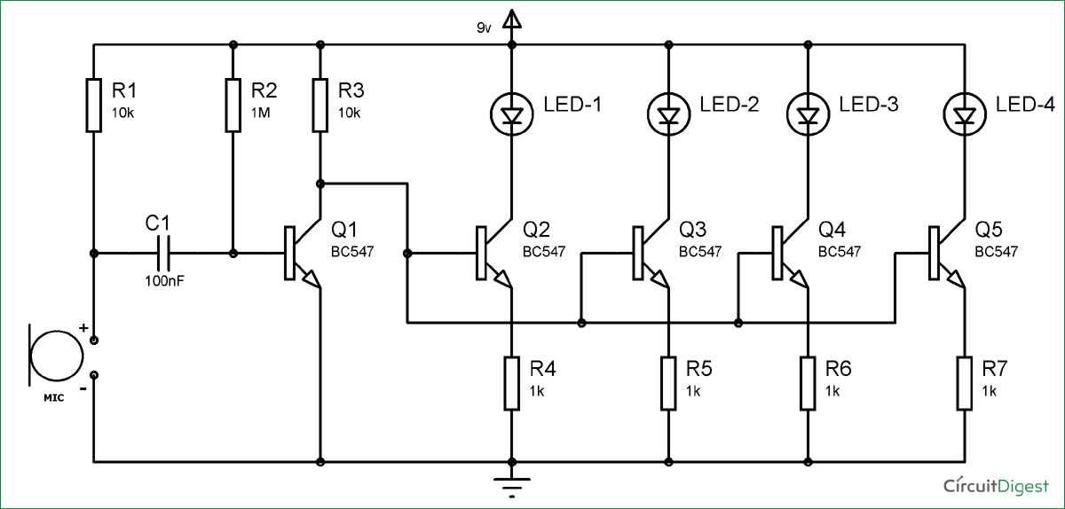

Figure 2: Li-Fi circuit

The proposed system consists of a solar panel, a speaker, a 9v battery, led light source and an audio jack to connect the speaker and smart phone. The audio signals from the smart phone are sent in the form of light signals through light source (LED). These light signals are made to fall on solar panel which convert light signals into electrical signals and transfer them to the speaker which is connected to it. The data is now transmitted, that is, in the form of light to the audio output (speaker). The major role is played by the Li-Fi circuitry where the input signal is amplified to enhance the signal strength and solar panel acts as source of energy to the smart phone and transmit input signal to the speaker. Thus data is transferred in the form of light and data is more securely transferred when compared to Wi-Fi.

**IV. APPLICATIONS AND FUTURE SCOPE**

Li-Fi applications are varied as a result of its key features such as directional lighting, energy efficiency, intrinsic security, high data rate capability, signal blocking by walls and integrated networking capability. In future applications such as VLC capable micro LEDs can be integrated into smart device displays and indicator lights, turning them into powerful data transmission ports. Truly we seem to be at a verge of VLC where every single pixel counts.

**V. CONCLUSION**

Li-Fi has wide range of applications in the field of wireless communication providing reliable data transfer and high rate of transmission up to gigabytes. Data is transferred with the visible light and is transmitted across the visible light spectrum. In field of data electronics, it provides ample ways to transfer signals and its relative data to the greatest accuracy and in the most precise way. Communicating and obtaining data from satellite will be easier than ever before. It will be beneficial for defense services as their data is very confidential and private and LIFI cannot be hacked so data is protected. Thus Li-Fi is the new renovation in the field of wireless communication.

**REFERENCES**

[1] https://www.ijert.org/future-of-wireless-technology-lifi

[2] http://www.lifi-centre.com/about-li-fi/applications/

[3] Ijarcsms_june_2015_li_fi_anurag_shalabh_asoke_30_06_2015

[4] International Advanced Research Journal in Science, Engineering & Technology (IARJSET) National Conference on Renewable Energy & Environment (NCREE-2015) IMS Engineering College, GhaziabadVol. 2, Issue 1, April 2015 by, Satyendra Kumar Gupta, AnuragAgrawal.